**Hardware simulation**

**Simulation-:**Say you want to build a circuit that does some kind of signal processing. You draw your schematic in a paper, make your hand calculations, select the components, build the circuit, turn it on, and it does not do what you were expecting... or even worse, it damages one or more components in the process. Finding the flaw in the circuit and even replacing the lost components may be a pain.

This chapter consist of the simulation done before implementing the actual circuits which gives us the advantages such as

* It is much faster to build the circuit in the simulator than in real life
* If it does not work at first, no harm done. It is easy to adjust and improve.
* You can access any node in the circuit with a click of the mouse, which makes debugging much faster.
* You can try components that you do not physically have.

Simulation software used for simulation -: Proteus

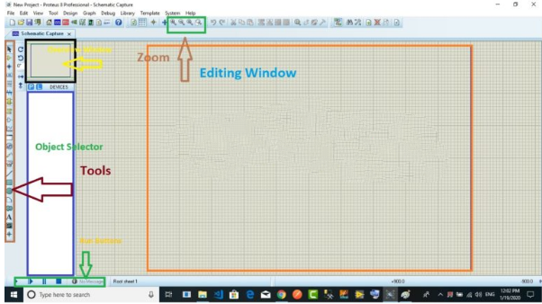

**Proteus**is used to simulate, design and drawing of electronic circuits. It was invented by the Labcenter electronic.By using proteus you can make two-dimensional circuits designs as well.With the use of this engineering software, you can construct and simulate different electrical and electronic circuits on your personal [computers](https://www.theengineeringknowledge.com/full-form-of-computer/) or laptops.There are numerous benefits to simulate circuits on proteus before make them practically.Designing of circuits on the proteus takes less time than practical construction of the circuit.The possibility of error is less in software simulation such as loose connection that takes a lot of time to find out connections problems in a practical circuit.Circuit simulations provide the main feature that some components of circuits are not practical then you can construct your circuit on proteus.There is zero possibility of burning and damaging of any electronic component in proteus.

The electronic tools that are very expensive can easily get in proteus such as an oscilloscope.Using proteus you can find different parents of circuits such as current, a voltage value of any component and resistance at any instant which is very difficult in a practical circuit.

**Simulation circuit**

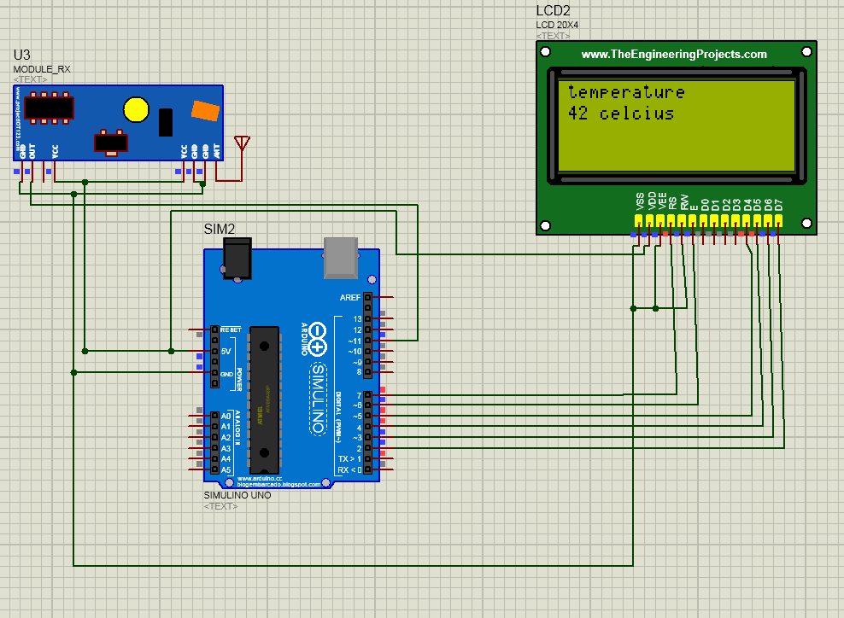

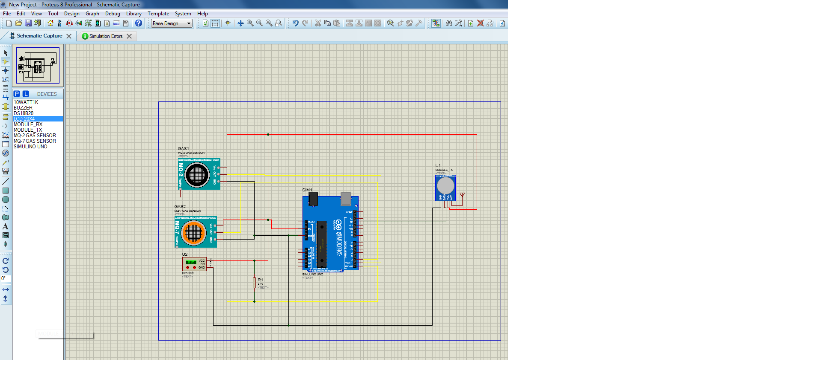

How to upload the code in arduino in proteus

* Wrie the code in the arduino ide
* Check whether the compilation option is checked to generate the hex file. It can be found from **File —> Preferences.**
* Compile the code and copy the hex file-path.
* Double click on the Arduino board to insert the hex file of code.
* After inserting a hex file, you can start the simulation by pressing the play key.
* Now the circuit will simulate and give the output as per program